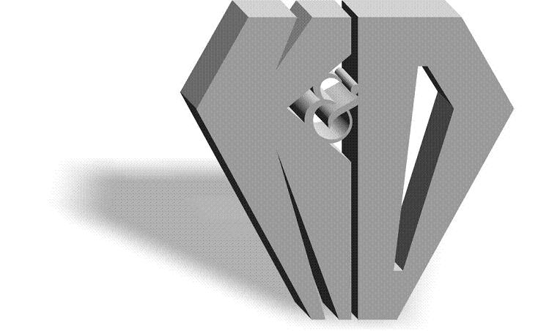K&D DIAMONDS, INC.

Manufacturers & Importers of Diamonds

580 Fifth Avenue Suite 711 New York, NY 10036

Tel: (212) 869-0811 1-877-869-0811 Fax (212) 869-0815

Website: www.kddiamonds.com

California’s “Lead-Containing Jewelry Law”
Compliant

K&D Diamonds does not intentionally add lead or cadmium to any of our jewelry products. K&D Diamonds receives written assurances from its jewelry manufacturers that products follow lead and cadmium policy. Products you purchase from K&D Diamonds do not contain a level of lead or cadmium that would prohibit the product from being sold or offered for sale pursuant to Article 10.1.1 Chapter 6.5, Division 20, of the California Health and Safety Code (Sections 25214.1-25214.4.2).

